Sign Language Recognition for Tamil: Survey, Challenges, and a Proposed Framework

1st A. Beulah
Artificial Intelligence and Data Science Rajalakshmi Engineering College Chennai, Tamil Nadu, India beulah.a@rajalakshmi.edu.in
ORCID: 0000-0002-3891-0806

4th Sukish M
Artificial Intelligence and Data Science Rajalakshmi Engineering College Chennai, Tamil Nadu, India 221801053@rajalakshmi.edu.in
2nd Nikilesh S
Artificial Intelligence and Data Science Rajalakshmi Engineering College Chennai, Tamil Nadu, India 221801035@rajalakshmi.edu.in
3rd Poongavin B
Artificial Intelligence and Data Science Rajalakshmi Engineering College Chennai, Tamil Nadu, India 221801036@rajalakshmi.edu.in

Abstract—The absence of efficient computational models for Tamil Sign Language interpretation has continued to pose a bar- rier to inclusive communication between the Tamil-speaking deaf and speech impaired community and the hearing community. This paper proposes a deep learning framework for translating Tamil Sign Language hand gestures to their corresponding text and synthesized speech. The proposed framework uses a vision- based approach with MediaPipe Hand Landmark Detection to extract 21 meaningful hand key points from hand gesture images, allowing for background-independent and robust feature representation. The extracted spatial landmark features are then processed using a deep Convolutional Neural Network with a ResNet50 architecture to learn discriminative patterns from a large and complex gesture vocabulary. The proposed framework is trained and tested on the TLFS23 Tamil Language Finger Spelling dataset, which contains 248 Tamil character classes and over 255,000 gesture images collected from multiple signers. The experimental results show the feasibility of accurate gesture recognition with computational efficiency suitable for real-time applications. The recognized Tamil characters are then converted to synthesized speech using a Text-to-Speech module, completing the end-to-end gesture-to-speech translation system. This pro- posed work is a step towards the development of scalable and region-specific sign language recognition systems and provides a strong foundation for future extensions such as continuous sign recognition and real-time assistive communication applications.
Index Terms—Accessibility, Assistive Technology, Computer Vision, Deep Learning, Hand Gesture Recognition, MediaPipe, ResNet50, Sign Language Recognition, Tamil Sign Language, Text-to-Speech, Vision-Based Recognition

- Introduction
Communication is a basic element of human interaction, which facilitates the process of information exchange, ex- pression of emotions, and involvement in social, educational, and professional activities [1]. For deaf and speech-impaired people, communication is carried out through sign languages, which are full-fledged natural languages with their own gram- mar, vocabulary, and linguistic rules. The lack of a common communication channel between sign language speakers and
people with normal hearing remains a major cause of obstruc- tion, hindering access to vital services and social integration. Sign languages are not global and differ greatly from region to region [2]. Although there has been considerable research work done on popular sign languages like American Sign Language (ASL) [3] and British Sign Language (BSL) [4], relatively less work has been done on regional and resource- constrained sign languages. Tamil Sign Language (TSL) [5], which is largely used in the Indian state of Tamil Nadu, is one of the less-studied sign languages. The absence of large datasets, proper representation, and robust models has impeded the development of efficient automated systems for
interpreting TSL.
Recent breakthroughs in computer vision and deep learning have made it possible to achieve substantial progress in Sign Language Recognition (SLR). Computer vision-based solutions, especially those based on Convolutional Neural Net- works (CNNs), have shown impressive results in recognizing hand signs without the use of wearable sensors. Moreover, hand tracking solutions based on landmarks, like MediaPipe [6], have also improved the recognition accuracy by providing accurate key points that remain unaffected by background noise and lighting conditions.
Despite these improvements, current SLR systems face scalability issues when dealing with sign languages that have extensive vocabularies and similar gesture patterns, such as TSL. Furthermore, most existing systems are limited to ges- ture classification and lack an end-to-end translation solution that translates identified signs into readable text or speech. Overcoming these issues is critical for the development of useful assistive communication systems that can be used in real-world settings.
In this paper, an end-to-end deep learning-based system for the translation of Tamil Sign Language hand gestures into corresponding text and synthesized speech is presented. The proposed system utilizes MediaPipe Hand Landmark
Detection to identify spatial hand features, which are then analyzed using a deep Convolutional Neural Network with a ResNet50 architecture [7] to identify distinctive hand gesture patterns. The system is trained and tested on the TLFS23 Tamil Language Finger Spelling dataset [8], which includes a full range of Tamil characters. By combining gesture recognition with a Text-to-Speech module, the proposed system provides an end-to-end gesture-to-speech translation system with the primary goal of enhancing accessibility and inclusivity for the Tamil deaf and speech impaired population.
- Related Works
The recognition of sign language through technological means has garnered significant research interest, with various approaches tailored to different sign languages and application contexts. In the realm of sign language recognition, deep learn- ing techniques have been prominently utilized, as evidenced by studies on Bangladeshi Sign Language (BdSL) employing Deep Convolutional Neural Networks (DCNNs) [16], and on Indian Sign Language (ISL) with a focus on bidirectional translation incorporating context and emotion [17]. These stud- ies highlight the effectiveness of convolutional neural networks and advanced models in capturing the complex handshapes and expressions characteristic of sign languages.
Vision-based methods form a core component of sign lan- guage recognition systems, with comprehensive reviews em- phasizing pre-processing, feature extraction, and classification stages. Bankar et al. [18] reviewed various computer vision techniques applied to hand gesture recognition, underscoring the importance of image processing and feature extraction in developing effective sign language systems. Similarly, Alam et al. [19] identified a research gap in smartphone-based sign language detection, emphasizing the potential of machine and deep learning approaches in mobile environments, and highlighting the need for further exploration in this area.
Electromyographic (EMG) signals have also been explored as an alternative modality for sign language recognition. Amor et al. [20] conducted a systematic review of EMG-based methods, providing insights into the techniques that utilize muscle activity signals for handshape recognition, which can complement vision-based systems or serve as standalone so- lutions.
In terms of application scope, speech-to-sign translation sys- tems have been developed to facilitate communication between deaf and hearing individuals. Peguda et al. [21] proposed models translating speech into sign language gestures, ad- dressing the limited research on Indian Sign Language and its practical deployment. Faisal et al. [22] extended this concept by integrating sign recognition, speech recognition, and avatar generation into a comprehensive system—the Saudi Deaf Companion System (SDCS)—which leverages a proprietary database to enhance communication.
Real-time translation remains a critical focus, with Pap- atsimouli et al. [23] emphasizing the importance of inte- grating sign language translation with IoT technologies to enable seamless, real-time communication. This aligns with
the broader goal of developing accessible, interactive systems for the deaf community.
While most studies focus on specific sign languages, there is a growing recognition of the need for bidirectional and context-aware translation systems. Acharya et al. [24] ad- dressed this by proposing a model that incorporates emotional and contextual understanding, moving beyond simple syntactic translation to a more holistic communication process. This approach aims to meet the diverse and nuanced needs of sign language users, emphasizing the importance of cultural and emotional factors in effective communication.
Overall, the literature indicates a trend towards multi- modal, real-time, and context-aware sign language recognition systems, with deep learning and computer vision techniques at the forefront. Despite these advances, challenges remain in developing universally applicable systems, especially for languages like TSL, which require tailored datasets and models to capture their unique linguistic features. The integration of various modalities, such as EMG signals and visual data, along with the development of mobile and IoT-compatible solutions, represents promising directions for future research in TSL recognition to text.
From the literature reviewed, it is evident that the over- whelming majority of SLR studies is centered on ASL or a few regional languages. There is a great need for system- level and real-time recognition of the Tamil Sign Language. The majority of the existing systems have a limited dataset and an improper treatment of large class sizes, without end- to-end translation systems. The need for the research is based on the above-mentioned gaps and aims to develop a well-grounded, scalable, and real-time Tamil Sign Language recognition system using MediaPipe-based landmark detection and CNN/ResNet50 deep learning models on the TLFS23 dataset. The need for region-specific assistive communication technology is directly addressed by the proposed system.
A summary of the existing system is presented in Table I.
- Proposed Tamil Sign Language Recognition
System
The proposed work presents a vision-based deep learning model to detect Tamil Sign Language (TSL) hand gestures and translating it to text as well as synthesised speech. It is made to work based on a commodity RGB camera as nothing of wearable sensors nor extra hardware are required. MediaPipe Hand Landmark Detection is utilized to recover 21 anatomically corresponding landmark coordinates of a hand gesture image which provides a compact and background- insensitive representation of the movement of the hands. The computed landmark features are normalised to compensate hand size, orientation and signer style variability in order to achieve robustness under real-world conditions.
The extracted normalized landmarks features are then fed to a deep Convolutional Neural Network (CNN) with ResNet50 to learn discriminative spatial patterns of the Tamil sign gestures. The model is tested on the TLFS23 Tamil Language Finger Spelling dataset containing 248 Tamil characters and
TABLE I
Comparison of Existing Sign Language Recognition Approaches

Study | Methodology | Dataset | Key Contribution
Sign Language Recognition using Spiking Neural Net- works [9] | Spiking Neural Networks (SNNs) | DVS128 Gesture, SL-Animals- DVS | Improved recognition accuracy with 25% lower power consumption, suitable for edge devices
Enhancing Sign Language Detection through MediaPipe and Convolutional Neural Networks (CNN) [10] | MediaPipe Hands + CNN | ASL Alphabet Dataset | Achieved 99.12% accuracy using landmark- based real-time sign recognition
Real-time Assamese Sign Lan- guage Recognition using Me- diaPipe and Deep Learning [11] | MediaPipe + Deep Learning | Assamese Sign Language Dataset | Demonstrated effective adaptation of deep learning models to regional sign languages
Active convolutional neural networks sign language (ActiveCNN-SL) framework: a paradigm shift in deaf-mute communication [12] | Optimized Convolutional Neural Network (ActiveCNN-SL) | ASL Alphabet, ASL-MNIST | Improved feature extraction and recognition accuracy while maintaining real-time per- formance for assistive communication sys- tems.
Using LSTM to translate Thai sign language to text in real time [13] | MediaPipe + LSTM | Thai Sign Language Dataset | Demonstrated effective temporal modeling for continuous sign translation
Real-time Norwegian sign lan- guage recognition using Medi- aPipe and LSTM [14] | MediaPipe + LSTM | NSL educational videos provided by Statped | The system focuses on identifying numeri- cal hand gestures representing values from 0 to 10 in NSL and translating them into text format.
Real-time vernacular sign lan- guage recognition using me- diapipe and machine learning [15] | MediaPipe + Support Vector Mach- nie (SVM) | Custom Dataset | Considers multiple sign language datasets, including ASL (alphabets and numbers), Indian Sign Language (alphabets), Turkish Sign Language (numbers), and Italian Sign Language (alphabets).

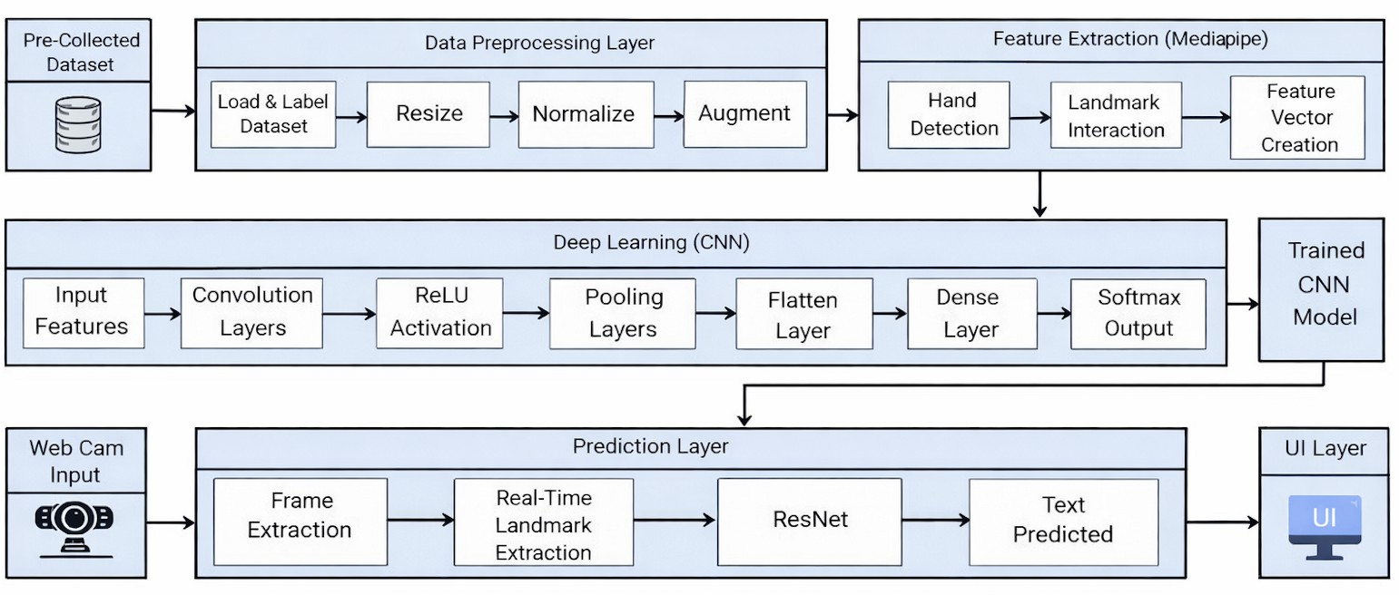

Fig. 1. Proposed Framework for Tamil Sign Language Recognition and Translation
more than 255,000 gesture images obtained from multiple signers. Upon detection, the classified Tamil characters are recognized into readable writing text and then transformed to spoken speech using a Text-to-Speech (TTS) module to output the end-to-end gesture-to-speech translation pipeline. The presented system offers a scalable base for regional sign language recognition and provides robustness for future extensions to continuous sign recognition as well as towards practical real-time assistive-communication algorithms. The architecture diagram depicting the proposed system is shown in the Figure 1.
- MediaPipe for Hand Landmark Extraction
MediaPipe is an open-source, real-time, cross-platform framework developed by Google for building perception pipelines [6]. In the proposed Tamil Sign Language recog- nition system, the MediaPipe Hand Landmark Detection al- gorithm is used to detect the hand key points from the input images and video streams. Unlike the traditional image-based feature extraction methods, MediaPipe offers a structured and semantically rich representation of the hand by identifying the critical anatomical points, which makes it highly suitable for sign language recognition systems.
Let an input RGB image or video frame be denoted as $I ∈ ℝH×W×3 .$
The MediaPipe hand tracking algorithm has two main stages: palm detection and hand landmark localization. Me- diaPipe first detects the hand region using a palm detector and extracts a bounded hand region of interest (ROI). From this ROI, a deep neural network estimates a set of 21 hand landmarks corresponding to anatomically meaningful points such as the wrist, finger joints, and fingertips

Each hand landmark is represented by a three-dimensional
coordinate:

$I_{i}=\left(x_{i},y_{i},z_{i}\right), i=1,2,…,21$ (1)

where xi and $yi$ denote the normalized spatial coordinates in the image plane, and zi represents the relative depth of the landmark with respect to the wrist. The complete landmark set for a given gesture is expressed as a landmark matrix:

$L= \left[x_{1} y_{1} z_{1} x_{2} y_{2} z_{2} x_{21} y_{21} z_{21} \right]∈R^{21×3}$ (2)

To achieve scale and translation invariance, the landmark coordinates are normalized with respect to the wrist landmark l1 and the maximum Euclidean distance between landmarks:

${l'}_{i}=\frac{l_{i}−l_{1}}{\max_{j}‖l_{j}−l_{1}‖}$(3)

The normalized landmark matrix L′ ∈ $ℝ$^{21×3} is then flattened into a feature vector:

f=[${x'}_{1},{y'}_{1}{,z'}_{1},. . . .,{x'}_{21}{,y'}_{21},{z'}_{21}$]$∈ ℝ^{63}$ (4)

This 63-dimensional feature vector captures the spatial con- figuration of the hand and is used as input to the deep learning classifier. The landmark-based representation improves robust- ness against background noise, illumination variations, and camera orientation while maintaining computational efficiency suitable for real-time Tamil Sign Language recognition. The landmark detection is shown in Figure 2.
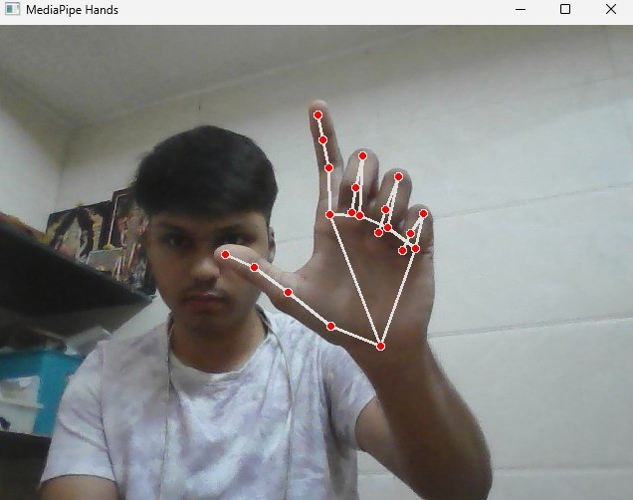
Fig. 2. Landmark detection

- Feature Preprocessing and Representation

The raw hand landmarks extracted using MediaPipe are preprocessed to reduce inter-signer variability and improve recognition robustness. Let the set of extracted landmarks be denoted as

$L =\{I_{i}=\left(x_{i},y_{i},z_{i}\right)\}\frac{21}{i=1}$ $(5)$
where (x_{i}, y_{i}, z_{i}) represent the spatial coordinates of the i^{th}
hand landmark.

  - Translation Normalization: To eliminate positional vari- ations caused by different hand locations within the image frame, all landmarks are translated with respect to the wrist landmark l₁:

$I_{i}^{(t)}=I_{i}−I_{1}, i=1,2,….,21$ (6)

  - Scale Normalization: To handle scale variations arising
from different hand sizes and camera distances, the translated
landmarks are normalized using the maximum Euclidean dis- tance from the wrist:

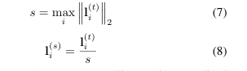
3) Feature Vector Construction: The scale-normalized landmark coordinates are concatenated to form a compact feature vector:

$f=\left[x_{1}^{\left(s\right)},y_{1}^{\left(s\right)},z_{1}^{\left(s\right)},….,x_{21}^{\left(s\right)},y_{21}^{\left(s\right)},z_{21}^{\left(s\right)}\right]∈ℝ^{63} (9)$

- Standardization:
To improve training stability and con- vergence, the feature vector is standardized using the mean µ and standard deviation σ computed from the training dataset:

$\hat{f}=\frac{f−μ}{σ}$ $(10)$

The resulting standardized feature vector f provides a nor- malized and discriminative representation of the hand gesture and is used as input to the deep learning classifier. This preprocessing ensures invariance to translation and scale while improving robustness across different signers and recording conditions.
- Deep Learning Model Architecture
The proposed system employs a deep learning classifier based on the ResNet50 architecture [7] to recognize Tamil Sign Language gestures from the preprocessed hand landmark features. ResNet50 is selected due to its deep representational capacity and the use of residual learning, which effectively mitigates the vanishing gradient problem and enables stable training of deep networks
Let the standardized feature vector obtained after preproessing be denoted as:

$\hat{f}∈ℝ^{63}$ (11)

This feature vector is reshaped and provided as input to the deep learning network. The initial layers of the model project the input features into a higher-dimensional space using fully connected and convolutional operations, enabling the network to learn complex spatial relationships among the hand landmarks.
The core of the architecture consists of stacked residual blocks, where each block learns a residual mapping instead of a direct transformation. A residual block can be mathemati- cally represented as:

$y = F(x, W) + x$ (12)

where x is the input to the block, $F(x, W)$ denotes the residual function learned by convolutional layers with weights $W$, and $y$is the output of the block. This residual connection
enables efficient gradient propagation during backpropagation and improves convergence.
The final layers of the network consist of a global average pooling layer followed by fully connected layers and a softmax classifier. For a classification task involving C = 248 Tamil character classes, the softmax output is given by:

$p(y=c|\hat{ f})=\frac{exp⁡(z_{c})}{\sum_{k=1}^{c}{}exp⁡(z_{k})}$ (13)
where z_{c} denotes the logit corresponding to the c^{th} class. The predicted class is obtained as:

$\hat{ y}=argmax c p(y=c|\hat{f}$) $(14)$

The network is trained using categorical cross-entropy loss and optimized using the Adam optimizer. This deep learning architecture effectively learns discriminative patterns from landmark-based features, enabling accurate and computation- ally efficient recognition of Tamil Sign Language gestures suitable for real-time applications
D. Training and Classification
The deep learning model is trained using the preprocessed hand landmark feature vectors extracted from the TLFS23 Tamil Language Finger Spelling dataset [8]. Each input sample is represented by a normalized feature vector
$\hat{f}∈ℝ^{63}$ (15)
with a corresponding ground truth class label
$y=\left\{1,2,….c\right\},$ (16)
where C = 248 denotes the total number of Tamil sign classes. During training, the model learns to map the input feature vectors to class probabilities through forward propagation. The output of the softmax layer produces a probability distribution
over all classes:

$p(y=c|\hat{ f})=\frac{exp⁡(z_{c})}{\sum_{k=1}^{c}{}exp⁡(z_{k})}$ (17)

where z_{c} is the logit value corresponding to the c^{th} class. The network parameters are optimized by minimizing the categorical cross-entropy loss function, defined as:

$ℒ=−\sum_{c=1}^{c}{}y_{c}log(p(y=c|\hat{f}$) (18)

where y_{c} is the one-hot encoded ground truth label.
The model is trained using the Adam optimizer [25] with adaptive learning rates, which enables faster convergence and stable training for deep networks. Mini-batch gradient descent is employed to update the network weights iteratively. Regu- larization techniques such as dropout and batch normalization are applied to reduce overfitting and improve generalization across different signers and gesture variations.
During the classification phase, unseen gesture samples are passed through the trained network, and the predicted class label is obtained using:

$\hat{y}=argmax c p(y=c|\hat{f}$) $(19)$

The recognized Tamil character is then forwarded to the text processing module and subsequently converted into synthe- sized speech using a TTS system. This completes the end-to- end pipeline for Tamil Sign Language gesture recognition and translation.
detected, tracked, and classified by the proposed system. The recognition process involves extracting hand landmarks from each frame, generating the corresponding feature represen- tation, and performing classification using the trained deep learning model.

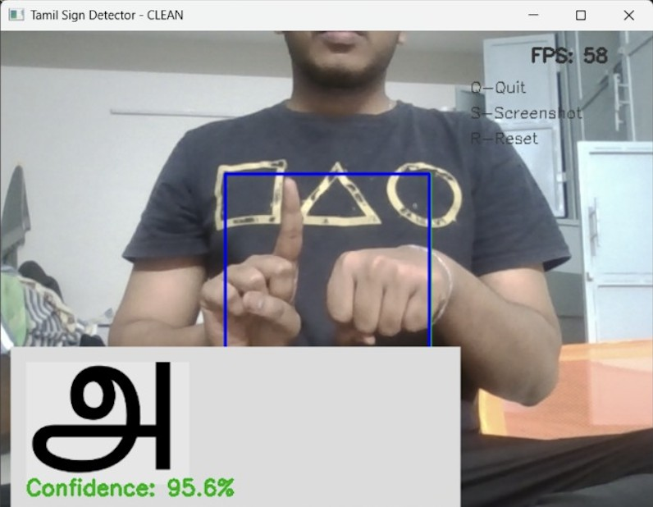
The system’s real-time recognition capability is illustrated in Fig. 3. As shown in the figure, the first Tamil character is accurately detected and correctly classified by the model, demonstrating the effectiveness and reliability of the proposed framework in practical deployment scenarios.
Fig. 3. Landmark detection

E. Text-to-Speech Conversion
After successful classification of the TSL gesture, the pre- dicted output class$y$ is mapped to its corresponding Tamil character or word in textual form. This textual representation serves as the input to the TTS module, which converts the recognized Tamil text into audible speech, thereby enabling effective communication with the hearing community.
Let the recognized text sequence be denoted as

$T = \{t1, t2, . . . , tn\}$ (20)

where t_{i} represents the i^{th} recognized Tamil character or token. The TTS system processes this text through a sequence of stages, including text normalization, phoneme generation, and acoustic modeling. Text normalization converts the raw output into a standardized linguistic format suitable for speech synthesis.
The phoneme sequence corresponding to the Tamil text is generated using language-specific pronunciation rules:

$P = Φ(T)$ (21)
where $Φ$(·) denotes the grapheme-to-phoneme (G2P) conver- sion function. The acoustic model then maps the phoneme sequence to a time-aligned acoustic feature representation:
$A = G(P)$ (22)
where $G$(·) represents the acoustic modeling function.
Finally, a vocoder synthesizes the speech waveform from
the acoustic features:
S = ν(A) (23)
where ν(·) denotes the waveform generation process. The synthesized speech output S corresponds to the recognized Tamil Sign Language gesture and is played in real time.The integration of the Text-to-Speech module completes the end-to-end gesture-to-speech translation pipeline, transforming visual hand gestures into intelligible spoken Tamil. This en- hances accessibility and usability of the system in real-world assistive communication scenarios.

IV.Conclusion

This paper presented a deep learning–based framework for translating Tamil Sign Language (TSL) hand gestures into corresponding text and synthesized speech, addressing the communication gap between the Tamil-speaking deaf and mute community and the hearing population. By leveraging a vision- based approach using MediaPipe hand landmark detection, the proposed system efficiently extracts discriminative spatial features while remaining robust to background variations and lighting conditions. The integration of landmark-based representation significantly reduces computational complexity compared to raw image processing, making the framework suitable for real-time applications.
A deep convolutional neural network with a ResNet50 backbone was employed to learn complex gesture patterns from the TLFS23 Tamil Language Finger Spelling dataset, which comprises 248 Tamil character classes and a large number of samples collected from multiple signers. The ex- perimental analysis demonstrates the feasibility of accurate and scalable gesture recognition for a low-resource regional sign language. Furthermore, the inclusion of a Text-to-Speech module completes an end-to-end gesture-to-speech translation pipeline, enabling intuitive and accessible communication.
Overall, the proposed framework establishes a strong foun- dation for region-specific sign language recognition systems and highlights the potential of deep learning techniques in assistive communication technologies. Future work will focus on extending the system to continuous and sentence-level sign recognition, improving temporal modeling, and deploying the framework on mobile and embedded platforms for broader real-world adoption.
References

- M. B. Jennings and L. Shaw, “Impact of hearing loss in the workplace: raising questions about partnerships with professionals,” Work, vol. 30, no. 3, pp. 289–295, 2008.
- A. Othman, “Sign language varieties around the world,” in Sign Lan- guage Processing: From Gesture to Meaning. Springer, 2024, pp. 41– 56.
- J. S. Pirone, K. K. Pudans-Smith, T. Ivy, and J. D. Listman, “The landscape of american sign language education,” Foreign Language Annals, vol. 56, no. 2, pp. 238–258, 2023.
- R. Wilks and R. O’Neill, “Integrating british sign language into deaf education,” The Language Learning Journal, pp. 1–12, 2025.
- P. Lingeswari, D. Pavunraj, M. Kanagavalli, and K. Manikandan, “Iden- tification of tamil sign language using hamiltonian deep neural network,” International Journal of Systems, Control and Communications, vol. 16, no. 1, pp. 62–78, 2025.
- C. Lugaresi, J. Tang, H. Nash, C. McClanahan, E. Uboweja, M. Hays,

F. Zhang, C.-L. Chang, M. G. Yong, J. Lee et al., “Mediapipe: A framework for building perception pipelines,” arXiv preprint arXiv:1906.08172, 2019.
- M. Chirranjeavi, S. Aaruran, V. Gokulraj, B. N. Binoy, M. Harikumar et al., “Tlfs23 tamil language fingerspelling dataset,” Data in Brief, vol. 52, p. 109961, 2024.
- M. Chirranjeavi, S. Aaruran, V. Gokulraj, B. N. Binoy, M. Harikumar et al., “Tlfs23 tamil language fingerspelling dataset,” Data in Brief, vol. 52, p. 109961, 2024.
- P. Chaudhari, A. Vicente-Sola, A. Basu, D. L. Manna, P. Kirkland, and G. Di Caterina, “Sign language recognition using spiking neural networks,” Procedia Computer Science, vol. 235, pp. 2674–2683, 2024.
- A. R. Verma, G. Singh, K. Meghwal, B. Ramji, and P. K. Dadheech, “En- hancing sign language detection through mediapipe and convolutional neural networks (cnn),” arXiv preprint arXiv:2406.03729, 2024.
- J. Bora, S. Dehingia, A. Boruah, A. A. Chetia, and D. Gogoi, “Real-time assamese sign language recognition using mediapipe and deep learning,” Procedia Computer Science, vol. 218, pp. 1384–1393, 2023.
- H. ZainEldin, N. A. Baghdadi, S. A. Gamel, M. Aljohani, F. M. Talaat,
  - Malki, M. Badawy, and M. Elhosseini, “Active convolutional neural networks sign language (activecnn-sl) framework: a paradigm shift in deaf-mute communication,” Artificial Intelligence Review, vol. 57, no. 6,
p. 162, 2024.
- W. Jintanachaiwat, K. Jongsathitphaibul, N. Pimsan, M. Sojiphan,
A. Tayakee, T. Junthep, and T. Siriborvornratanakul, “Using lstm to translate thai sign language to text in real time,” Discover Artificial Intelligence, vol. 4, no. 1, p. 17, 2024.
- M. Z. Uddin, C. Boletsis, and P. Rudshavn, “Real-time norwegian sign language recognition using mediapipe and lstm,” Multimodal Technolo- gies and Interaction, vol. 9, no. 3, p. 23, 2025.
- A. Halder and A. Tayade, “Real-time vernacular sign language recogni- tion using mediapipe and machine learning,” Journal homepage: www. ijrpr. com ISSN, vol. 2582, no. 7421, p. 2, 2021.
- A. Haque, R. A. Pulok, M. M. Rahman, S. Akter, N. Khan, and
S. Haque, “Recognition of bangladeshi sign language (bdsl) words using deep convolutional neural networks (dcnns),” Emerging Science Journal, vol. 7, no. 6, pp. 2183–2201, 2023.
- R. Rastgoo, K. Kiani, and S. Escalera, “Sign language recognition: A deep survey,” Expert Systems with Applications, vol. 164, p. 113794, 2021.
- A. S. Bankar, A. Harale, and K. Karande, “Gestures controlled home automation using deep learning: A review,” International Journal of Current Engineering and Technology, vol. 11, no. 06, pp. 617–621, 2021.
- I. Alam, A. Hameed, and R. A. Ziar, “Exploring sign language detection on smartphones: A systematic review of machine and deep learning approaches,” Advances in Human-Computer Interaction, vol. 2024, no. 1, p. 1487500, 2024.
- A. Ben Haj Amor, O. El Ghoul, and M. Jemni, “Sign language recognition using the electromyographic signal: a systematic literature review,” Sensors, vol. 23, no. 19, p. 8343, 2023.
- J. Peguda, V. S. S. Santosh, Y. Vijayalata, A. Deepa, and V. Mounish, “Speech to sign language translation for indian languages,” in 2022 8th international conference on advanced computing and communication systems (ICACCS), vol. 1. IEEE, 2022, pp. 1131–1135.
- M. Faisal, M. Alsulaiman, M. Mekhtiche, B. M. Abdelkader, M. Algabri,
T. B. S. Alrayes, G. Muhammad, H. Mathkour, W. Abdul, Y. Alohali et al., “Enabling two-way communication of deaf using saudi sign language,” IEEE Access, vol. 11, pp. 135 423–135 434, 2023.
- M. Papatsimouli, P. Sarigiannidis, and G. F. Fragulis, “A survey of advancements in real-time sign language translators: integration with iot technology,” Technologies, vol. 11, no. 4, p. 83, 2023.
- A. Acharya, N. Patil, U. Pathak, and S. Bhagwat, “Sign language translation with fusion of emotion detection,” in 2024 8th International Conference on Computing, Communication, Control and Automation (ICCUBEA). IEEE, 2024, pp. 1–6.
- O. Hospodarskyy, V. Martsenyuk, N. Kukharska, A. Hospodarskyy, and S. Sverstiuk, “Understanding the adam optimization algorithm in machine learning,” 2024, 2024.

